The Female Pelvis

What is the female pelvis? The pelvis is the lower part of the torso. It's located between the abdomen and the legs. This area provides support for the intestines and also contains the bladder and reproductive organs.

Activity: Please now label the Pelvis as best you can and then do a search on google to check your answers: this is printable.

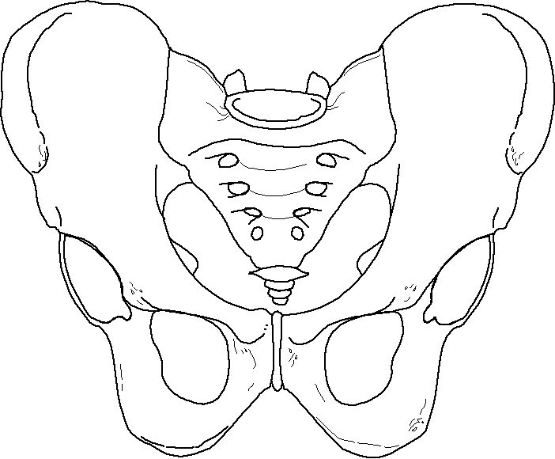

Sacroiliac joint
Sacrum
Illium
Obturator foramen
pubic symphysis
Pubis
Ischium
Acetabulum

Explore what each of them mean and make some notes on this.
Please see extended learning Link: Pelvis

