Breast Anatomy and Physiology

Breastfeeding is a key component for midwives to discuss with women and pregnant people. It is helpful for you to understand the structures of the breast.
Please see the diagram below and label the diagram correctly: this is printable.

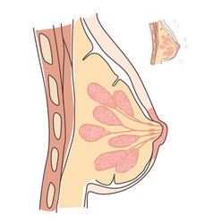
Nipple
Areola
Lobes/Lobules
Milk Reservoirs
Lactiferous Ducts
Montgomery’s Tubercles

Take a few moments to research and look up how it all works.

A really good video to watch is Breast Anatomy and Lactation

